Name:B.Srujan H.No:2303A51805 Batch:26
SCHOOL OF COMPUTER SCIENCE AND ARTIFICIAL INTELLIGENCE |  |  |  |  | DEPARTMENT OF COMPUTER SCIENCE ENGINEERING
Program Name: B. Tech |  |  |  | Assignment Type: Lab |  |  | Academic Year:2025-2026
Course Coordinator Name |  |  |  | Dr. Rishabh Mittal
Instructor(s) Name |  |  |  | Mr. S Naresh Kumar  Ms. B. Swathi  Dr. Sasanko Shekhar Gantayat  Mr. Md Sallauddin  Dr. Mathivanan  Mr. Y Srikanth  Ms. N Shilpa  Dr. Rishabh Mittal (Coordinator)  Dr. R. Prashant Kumar  Mr. Ankushavali MD  Mr. B Viswanath  Ms. Sujitha Reddy  Ms. A. Anitha  Ms. M.Madhuri  Ms. Katherashala Swetha  Ms. Velpula sumalatha  Mr. Bingi Raju
CourseCode |  |  | 23CS002PC304 | Course Title |  | AI Assisted Coding
Year/Sem |  |  | III/II | Regulation |  | R23
Date and Day  of Assignment |  |  | Week10 – Wednesday | Time(s) |  | 23CSBTB01 To 23CSBTB52
Duration |  |  | 2 Hours | Applicable to  Batches |  | All batches
Assignment Number:19.3(Present assignment number)/24(Total number of assignments)
 | Q.No. | Question |  |  |  |  |  | Expected Time  to complete
 | 1 | Lab 19 – Code Translation: Converting Between Programming Languages  Lab Objectives:  - Understand how AI tools can assist in translating code between different programming languages.  - Learn to verify correctness and functionality after translation.  - Explore syntactic and semantic differences between languages (e.g., Python, Java, C++).  - Practice debugging and optimizing AI-translated code. |  |  |  |  |  | Week10 - Wednesday
Task 1 – Python to C++ Conversion
Task:
Translate a simple Python class into C++ using AI assistance.
Instructions:
- Prompt AI to convert a Python class representing a Student with attributes and methods into equivalent C++ code
- Ensure proper handling of:
  - Constructors
  - Data types
  - Access specifiers
- Compile and run both versions to verify output consistency
Expected Output:
An equivalent working C++ class translated from Python.

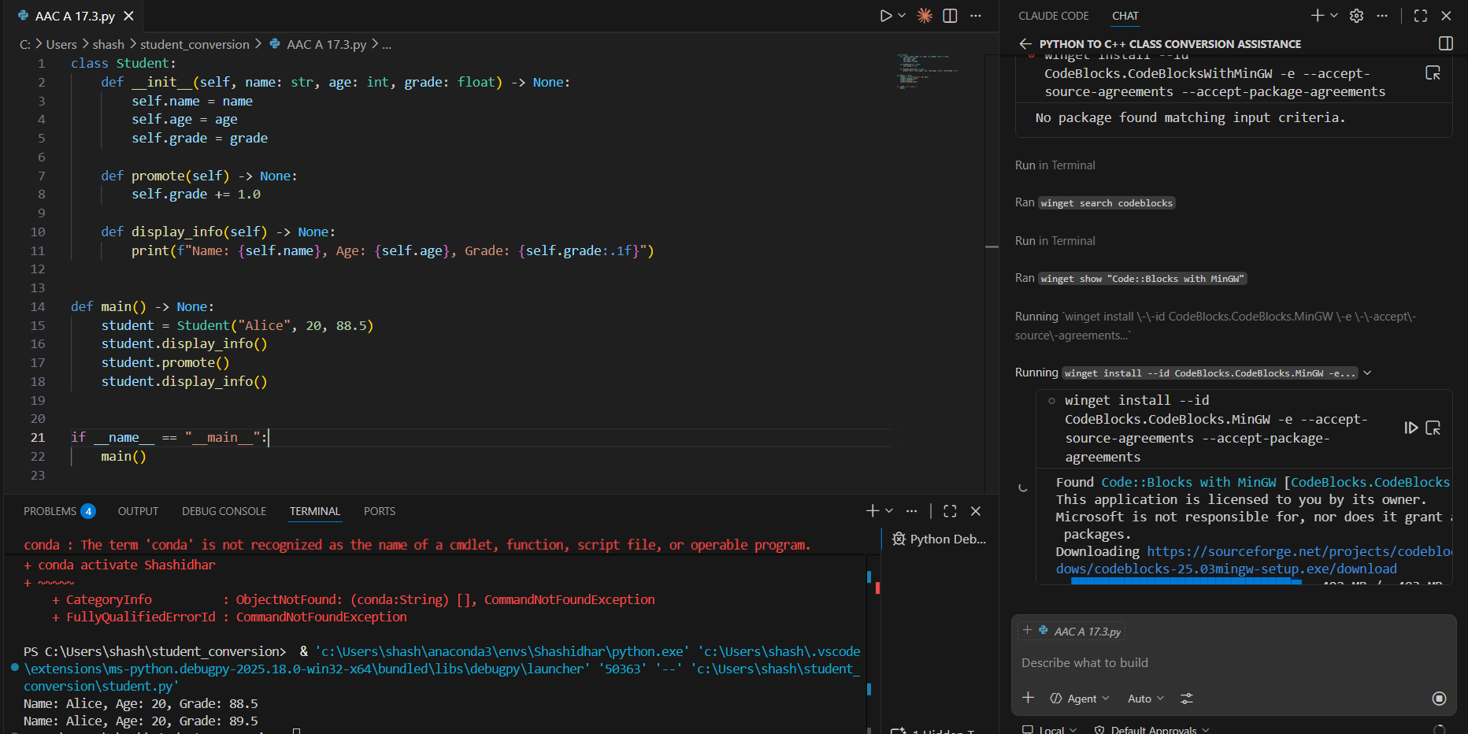

Task 2 – Java to Python Function Conversion
Task:
Convert a Java method that checks whether a number is prime into Python.
Instructions:
- Ask AI to translate a Java isPrime() method into Python
- Test the function with multiple inputs
- Ensure the Python version follows Pythonic syntax and logic
Expected Output:
A correct Python function equivalent to the original Java prime-checking method.

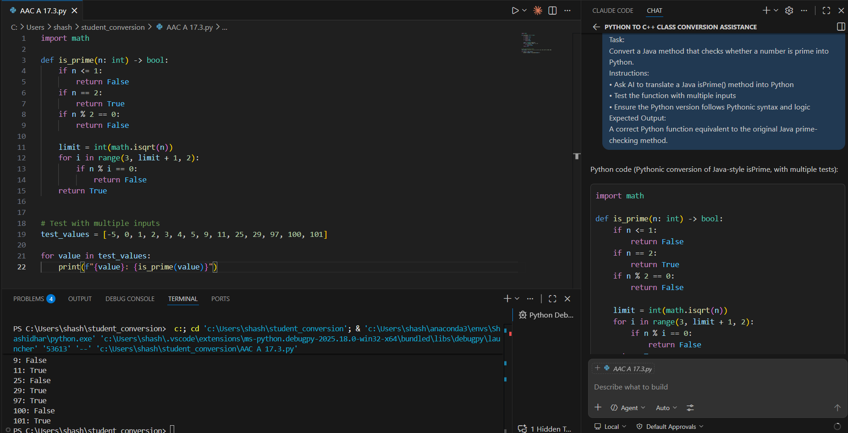

Task 3 – Pseudocode to Python Implementation
Task:
Translate a given pseudocode algorithm into Python using AI.
Instructions:
- Provide AI with pseudocode for sorting numbers (e.g., bubble sort or selection sort)
- Ask AI to convert it into executable Python code
- Validate correctness using sample input lists
Expected Output:
A working Python program that correctly implements the pseudocode logic.

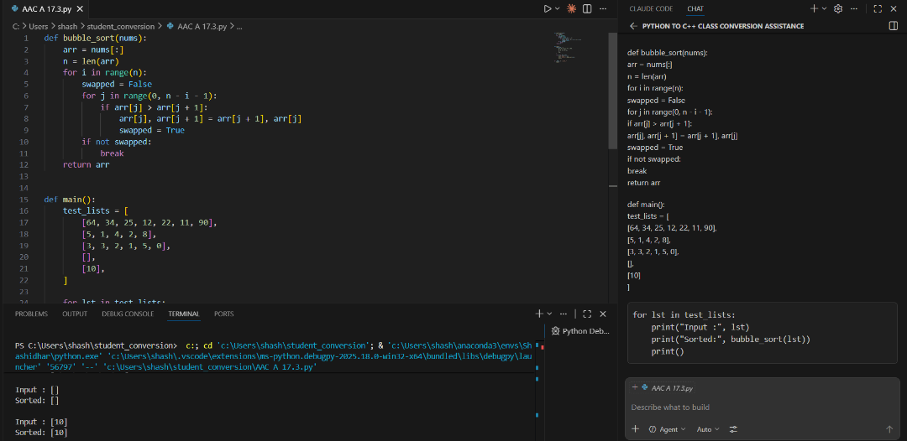

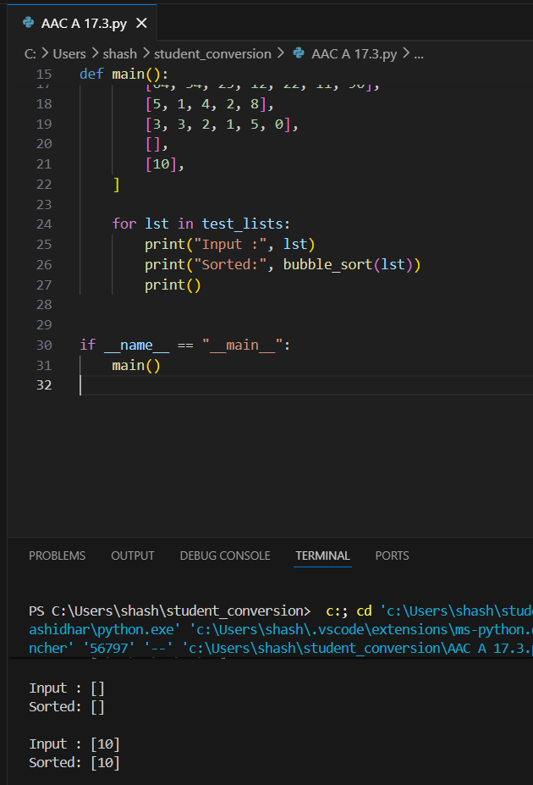

Task 4 – SQL to Pandas Query
Task:
Translate a SQL query into a Pandas DataFrame operation in Python.
Instructions:
- Provide AI with a SQL query (e.g., SELECT name, salary FROM employees WHERE salary > 50000).
- Ask AI to generate equivalent Pandas code.
- Test the generated code on a sample DataFrame.
Expected Output:
- Equivalent Pandas query that retrieves the correct subset of data.

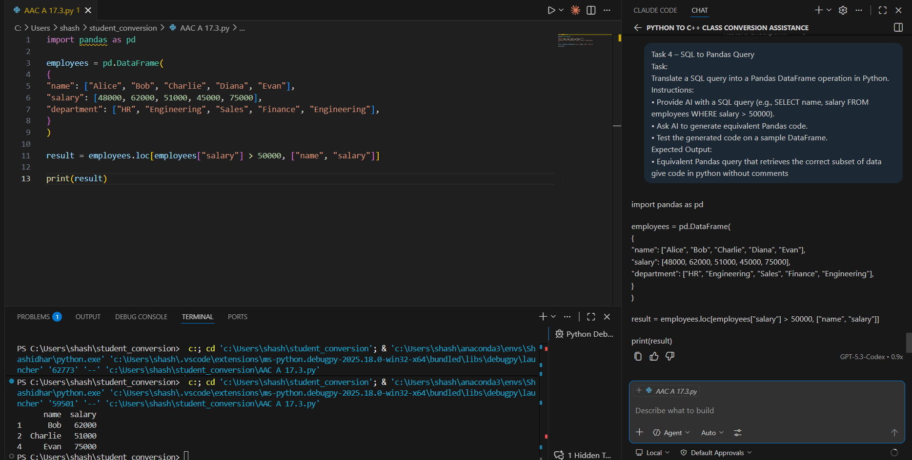

Task 5 – Real-Time Application: Algorithm Translation Across Languages
Scenario:
A company maintains algorithms written in different programming languages.
Examples:
- Converting a Python searching algorithm into C
- Translating a Java sorting program into JavaScript
Instructions:
- Use AI to translate a selected algorithm between two programming languages
- Execute and test both versions
- Document translation challenges such as:
  - Syntax differences
  - Library support
  - Memory management
Expected Output:
Equivalent, tested code implementations in two different programming languages.

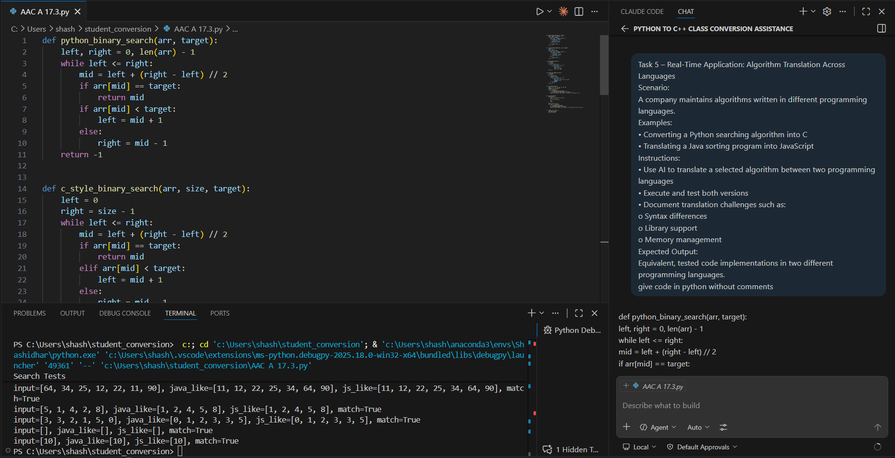

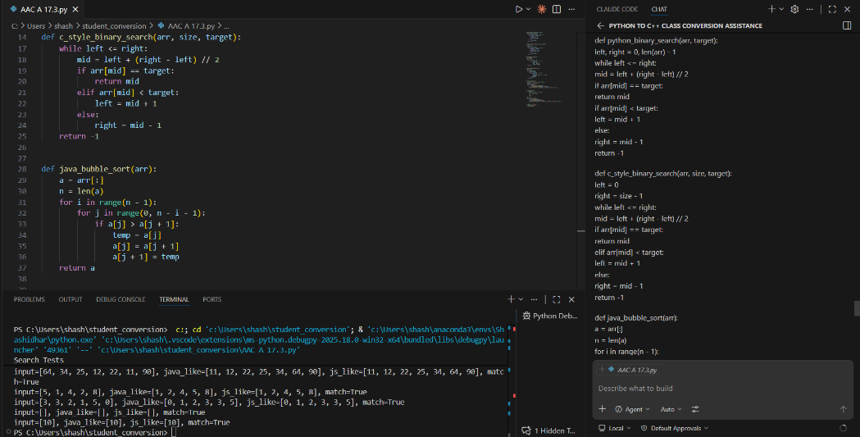

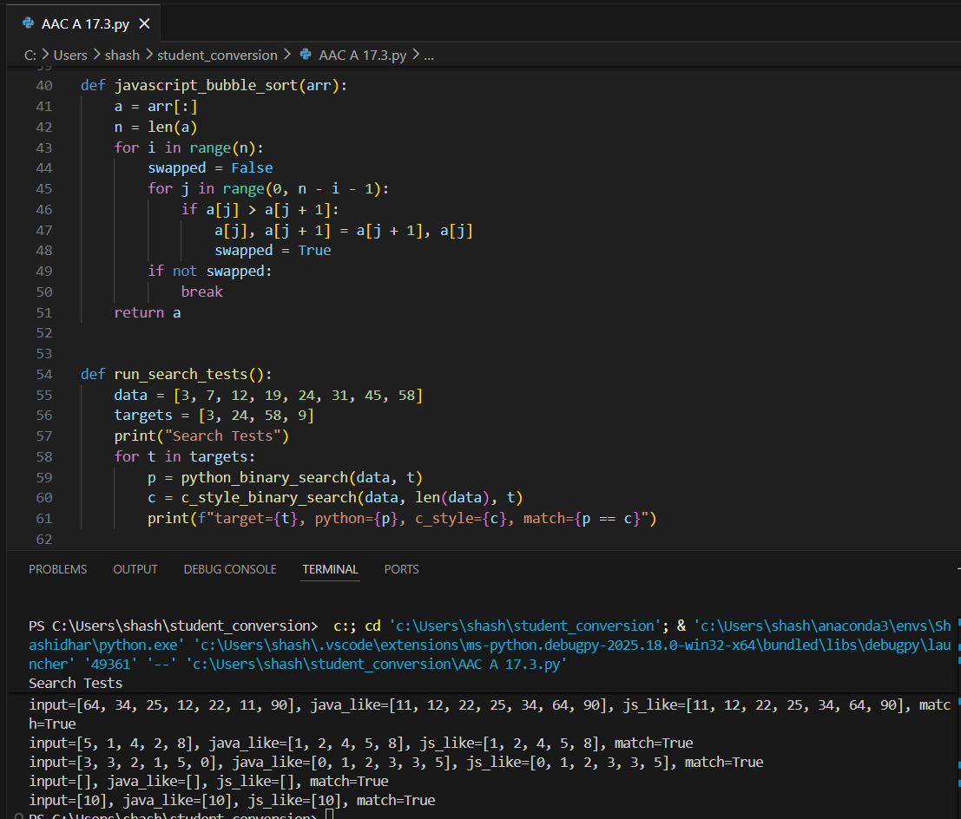
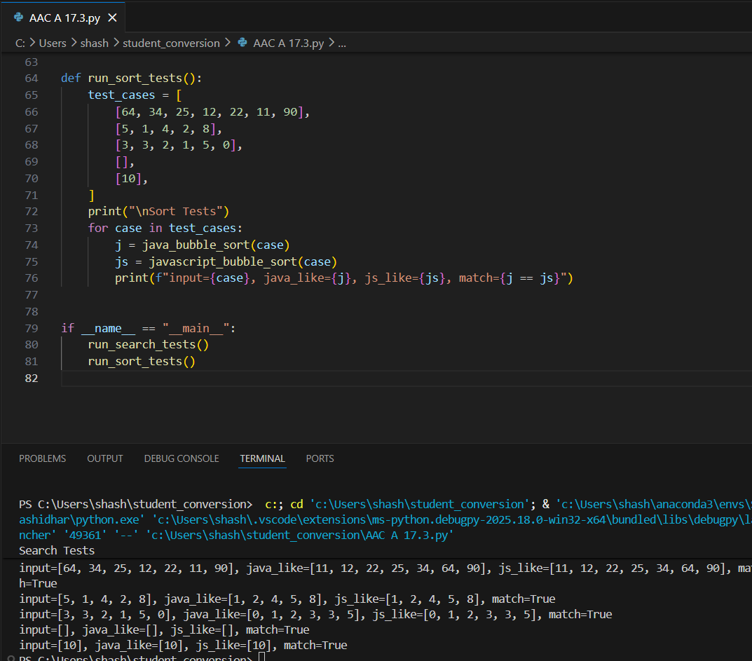
Note: Report should be submitted as a word document for all tasks in a single document with prompts, comments & code explanation, and output and if required, screenshots.

